Jenkins task for Assignment-01

1) Install Jenkins and run Jenkins on port number 8081.

2) Secure Jenkins server

3) Create users called DevOps, Testing in Jenkins with Limited access.

4) Configure labels and restrict the jobs to execute based on label only.

5) Create Three sample jobs using the below URL.

<https://github.com/betawins/Techie_horizon_Login_app.git>

6) Create one Jenkins job using git hub Private repository.

GitHub**GitHub**

[**GitHub - betawins/Techie_horizon_Login_app**](https://github.com/betawins/Techie_horizon_Login_app.git)

**Jenkins task for Assignment-01**

**1) Install Jenkins and run Jenkins on port number 8081.**

1. Create EC2 and get package of jenkin from website and then install java.
2. **Install java 17 version → sudo dnf install -y java-17-amazon-corretto**
3. **Install jenkins → sudo yum install jenkins**
4. **sudo systemctl enable jenkins**
5. **sudo systemctl start jenkins**
6. **sudo systemctl status jenkins**
7. 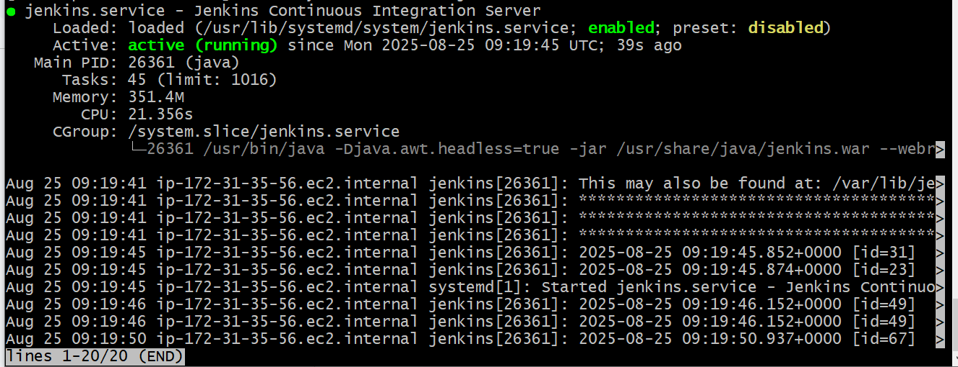
8. 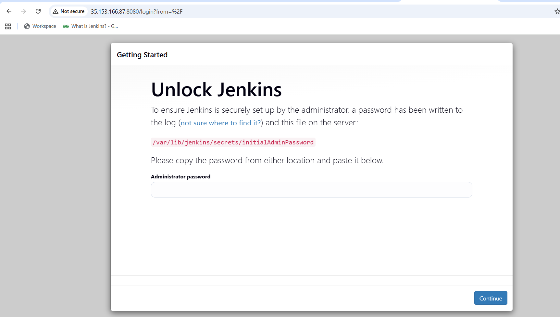
9. **Now changing port number to 8081**
10. **Now go to → sudo vi /usr/lib/systemd/system/jenkins.service**
11. **Update → Environment="JENKINS_PORT=8081"**
12. **sudo systemctl daemon-reexec**
13. **sudo systemctl daemon-reload**
14. **sudo systemctl restart jenkins**
15. **Now check in browser public-ip-of-EC2:8081**
16. 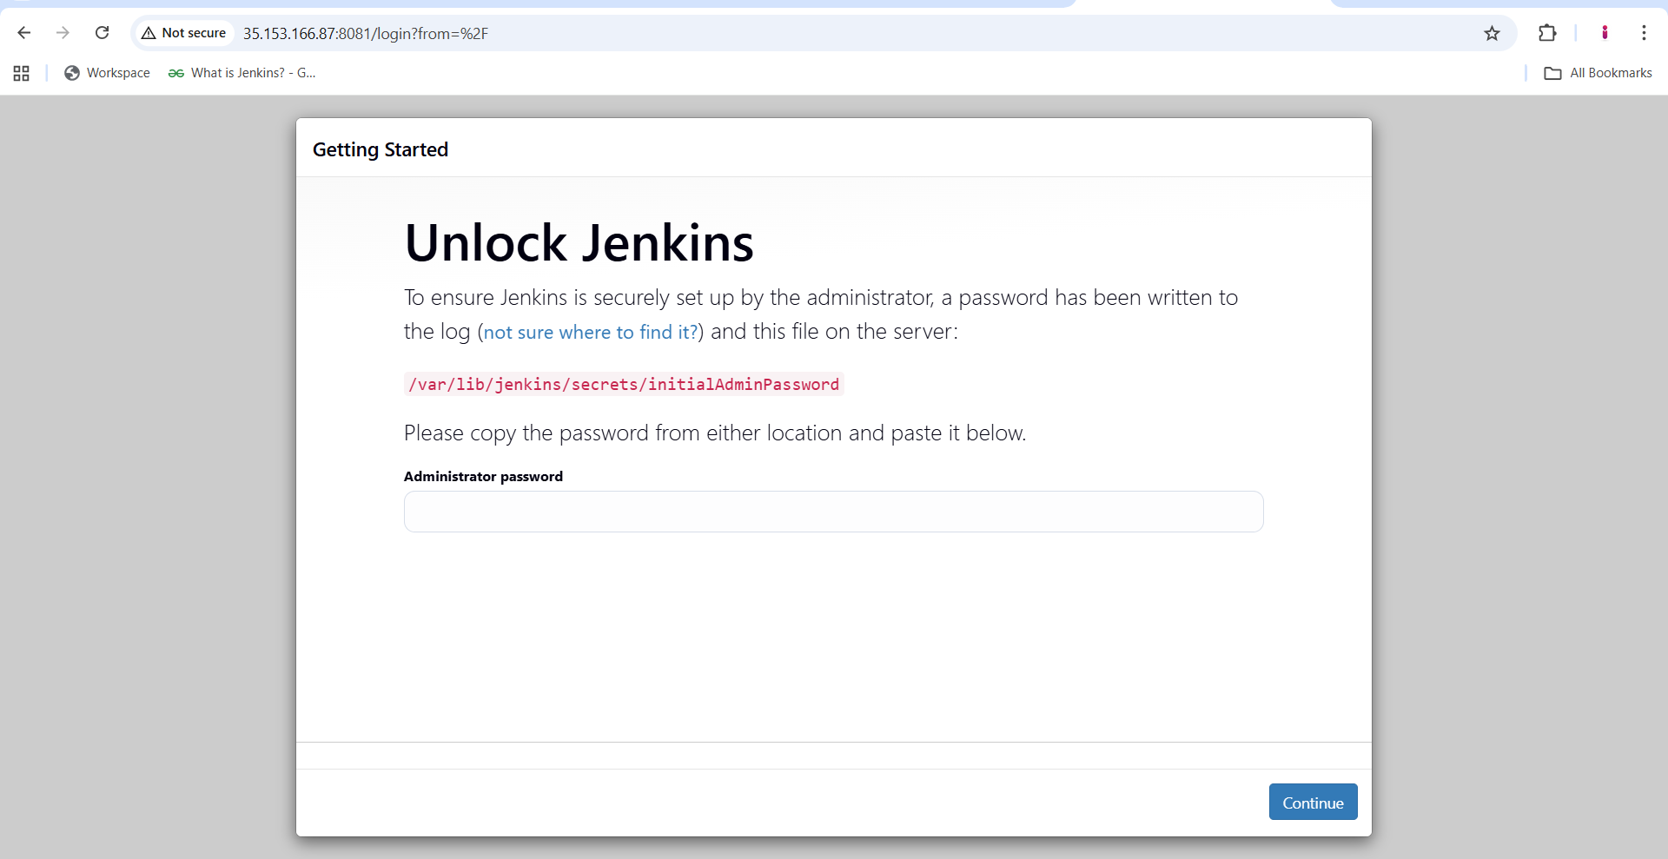
17. **Install bitbucket plugin in jenkins**
18. **Install git in EC2**

**2) Secure Jenkins server**

1. **Check the password and login to jenkins → cd /var/lib/jenkins/secrets**
2. **Cat initialAdminPassword**
3. **Now login to jenkins**
4. **Change password click on profile pic. jenkins → admin → security**
5. 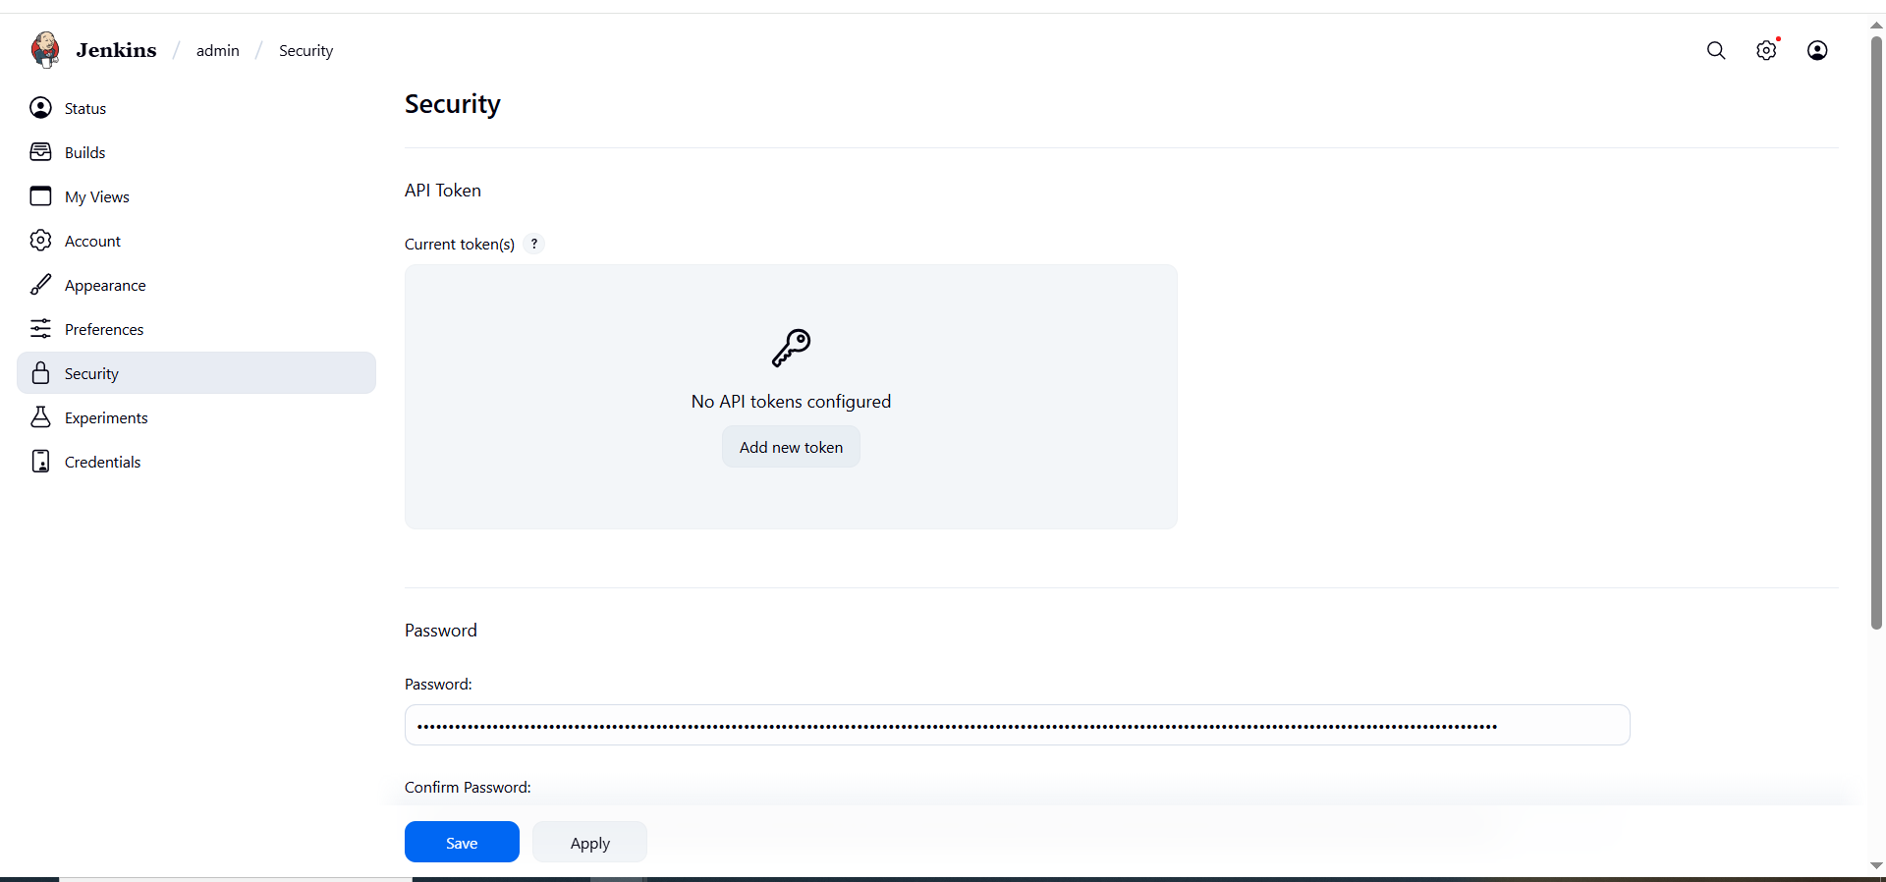

**3) Create users called DevOps, Testing in Jenkins with Limited access.**

1. **Goto → manage jenkins → users then create devops and testing users**
2. 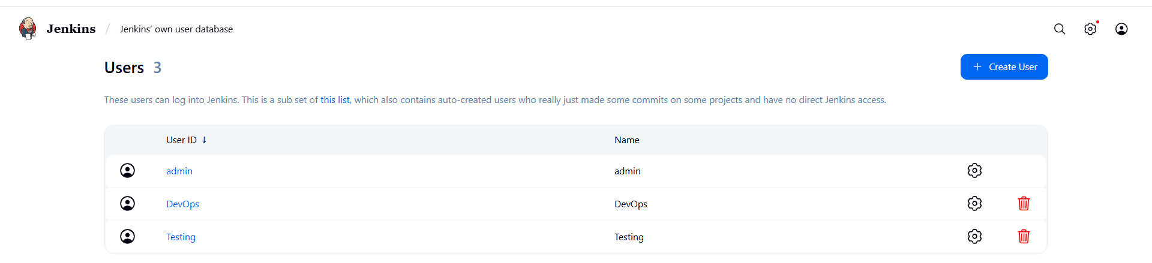
3. **Install plugin role-based authorization strategy**
4. 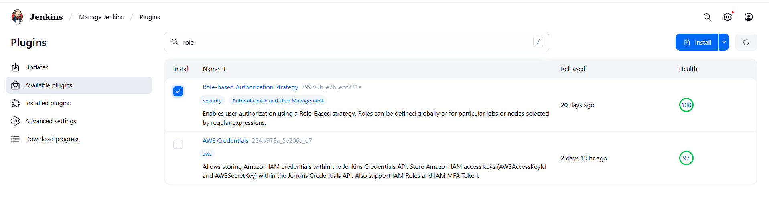
5. **Manage jenkins → security → authorization(project-based…..)**
6. 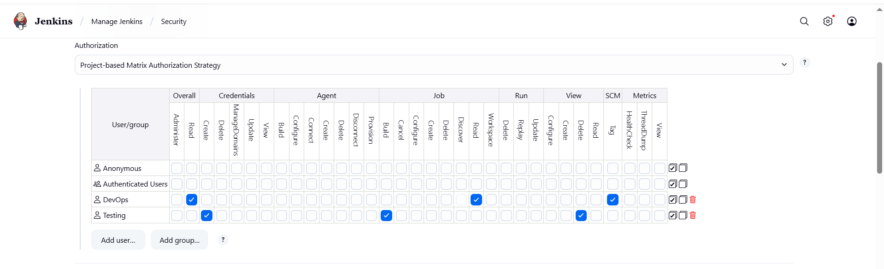
7. 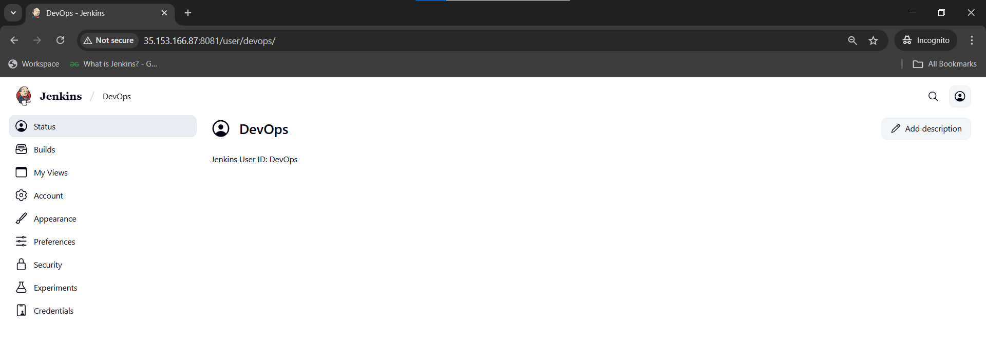
8. 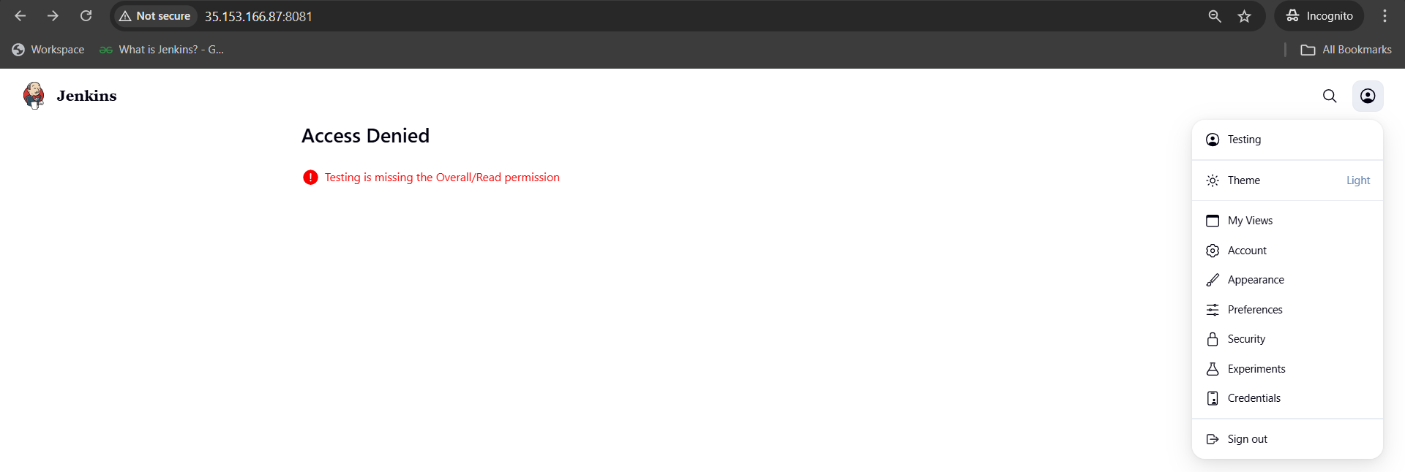

**4) Configure labels and restrict the jobs to execute based on label only.**

1. **Install GIT**
2. **Manage jenkins → system → create label Master**
3. **Create first job having label Master**
4. **Create second job without label Master**
5. **Create third job with wrong label hotfix**
6. **In each job → configure → build steps → execute shell → give seconds**
7. **I Got an issue with disk space**
8. 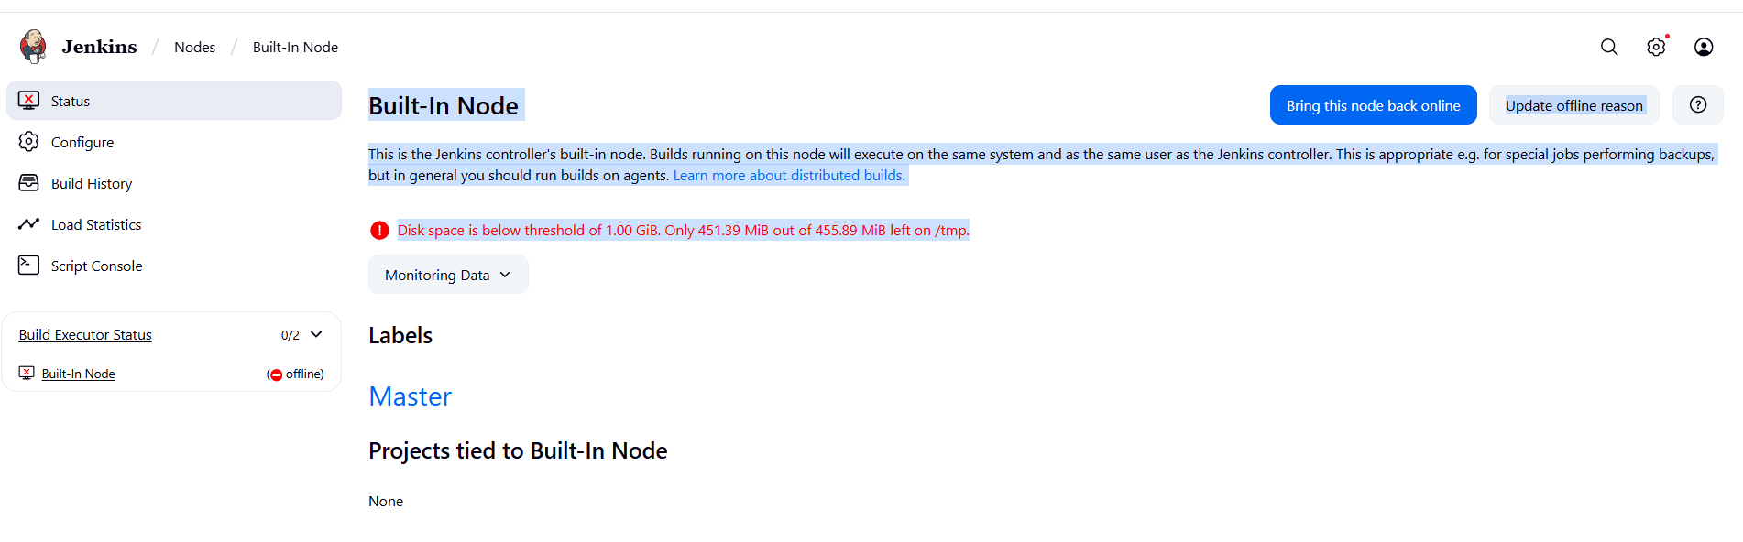
9. **Change Jenkins temporary directory (recommended)** 
   1. **Point Jenkins to use /var/lib/jenkins/tmp (on your main disk, which has ~18 GB free):**
   2. **Create a new tmp directory:  
      sudo mkdir -p /var/lib/jenkins/tmp**

**sudo chown -R jenkins:jenkins /var/lib/jenkins/tmp**

* 1. **Add below temp file → sudo systemctl edit jenkins**
  2. **[Service]**

**Environment="JAVA_OPTS=-Djava.io.tmpdir=/var/lib/jenkins/tmp"**

* 1. **Then reload**

**sudo systemctl daemon-reload**

**sudo systemctl restart jenkins**

1. **Install bitbucket plugin**
2. 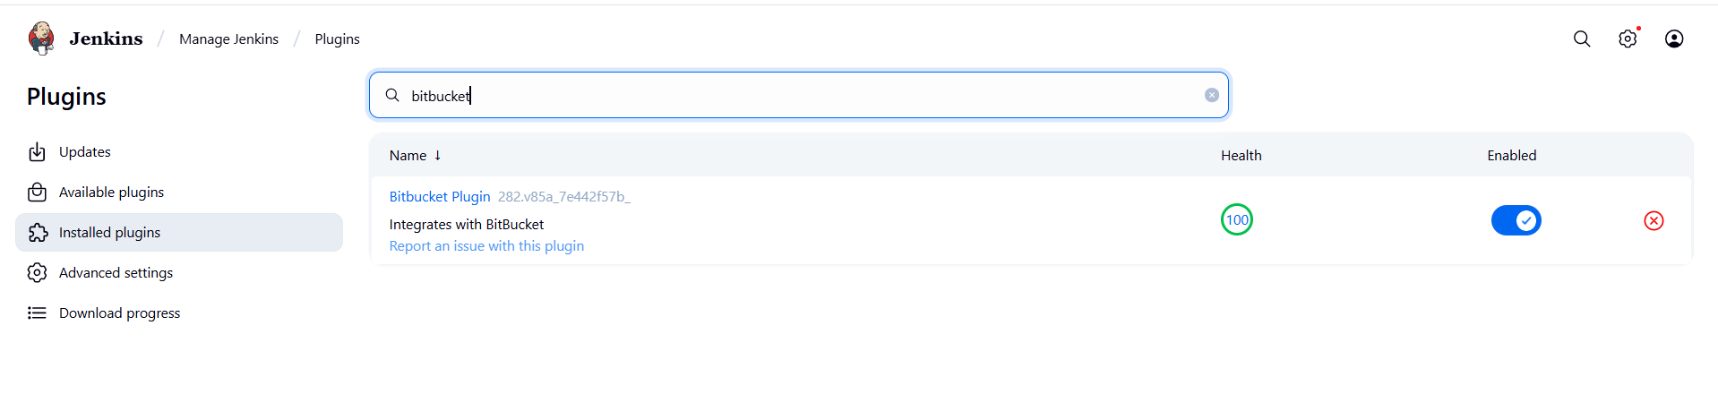
3. **First job only executed because its having label Master other jobs not connected to label Master**
4. 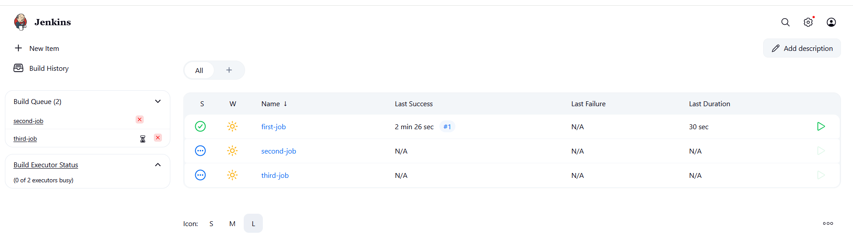

**5) Create Three sample jobs using the below URL.**

[**https://github.com/betawins/Techie_horizon_Login_app.git**](https://github.com/betawins/Techie_horizon_Login_app.git)

1. **Created three different jobs with different time stamps with label master i already in jenkins configured label as master.**
2. 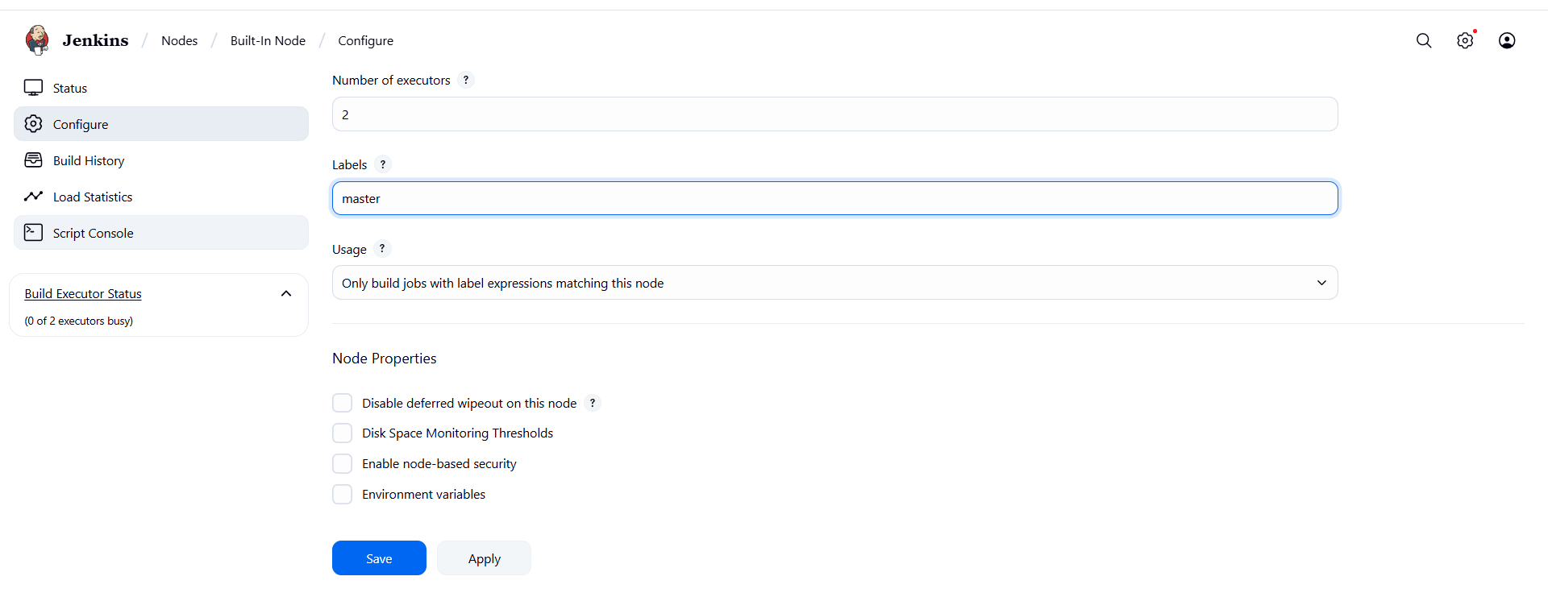
3. **Taken above url and once created then do build**
4. 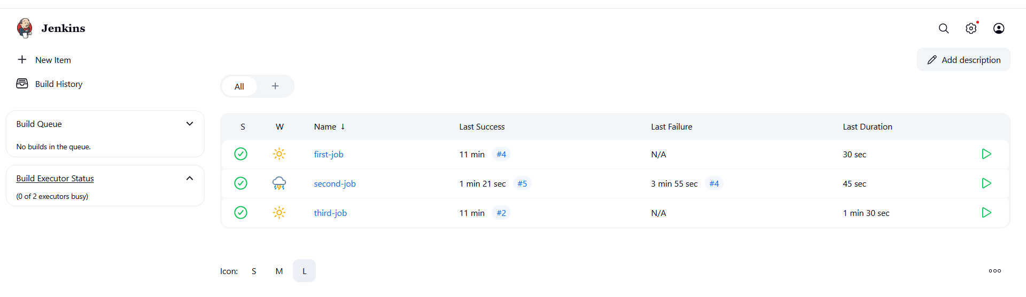

**6) Create one Jenkins job using git hub Private repository.**

1. **Create a private repo in GITHUB.**
2. **Go to github and create access token with repo**
3. **Goto → github → settings → developer settings → personal access token (pat) → token(classic) → create new token**
4. 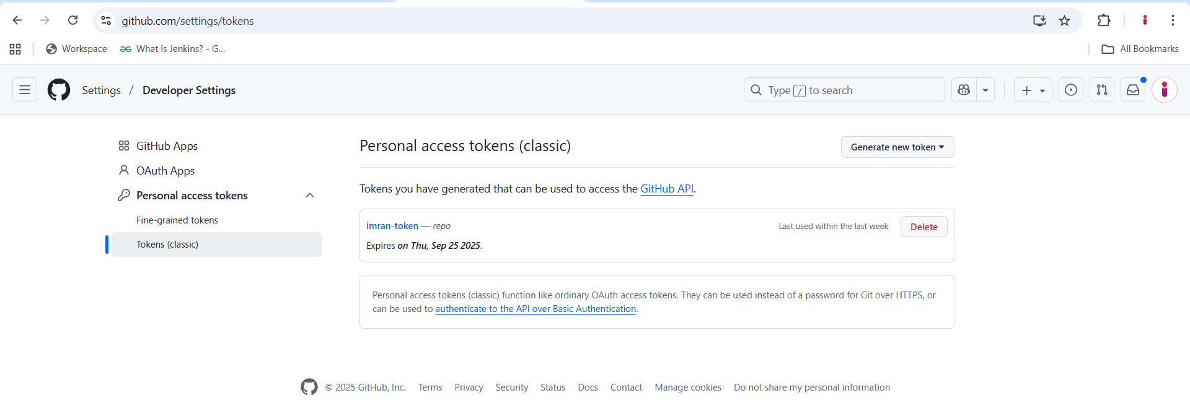
5. **In jenkins create credentials with github username and generated pat**
6. **Manage jenkins → credentials → system → global credentials**
7. 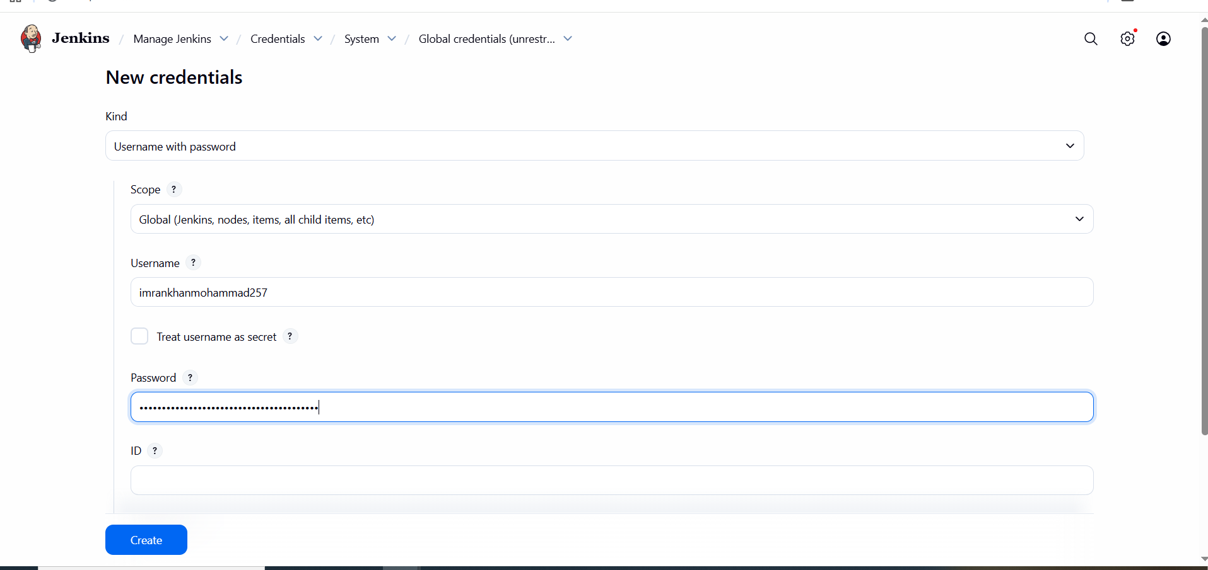
8. **Create private job with github private repo url with credentials**
9. **And add label, add git credentials save and run build.**
10. 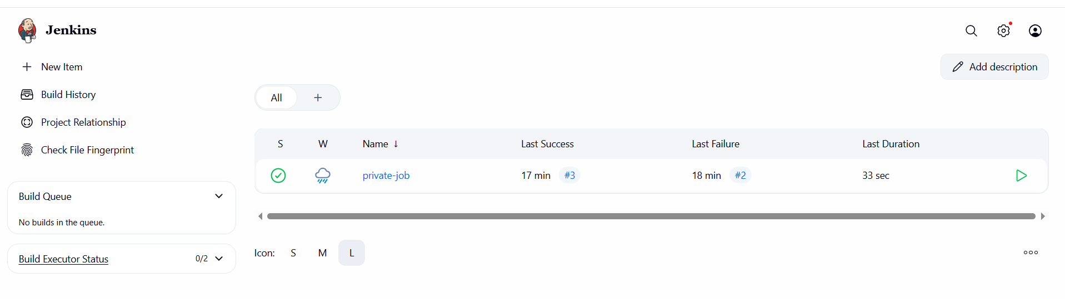
11. 